PA1_template

Monica Mitchell (mb1773)

Wednesday, February 11, 2015

## Loading and preprocessing the data

## Set working directory  
  
setwd("c:/coursera/")  
  
## Read Source Data  
  
actdata <- read.csv('activity.csv')

## What is mean total number of steps taken per day?

## Calculate total steps per day without   
## regard to rows with NA  
  
totalstepsperday <- tapply(actdata$steps, actdata$date, sum)

## Histogram of total steps taken each day  
  
hist(totalstepsperday, breaks = 5, main = "Number of Steps Taken Per Day",   
 xlab = " # of Steps", ylab = "# of Days in Group", col = "Blue")

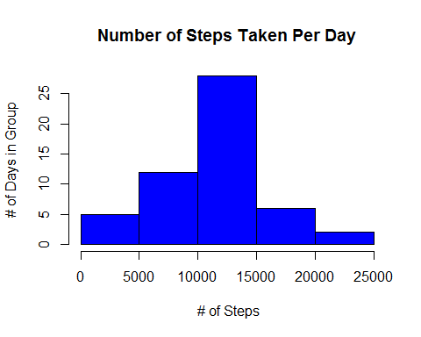

## Calculate Mean Steps per Day  
  
meanstepsperday <- mean(totalstepsperday, na.rm = T)  
meanstepsperday

## [1] 10766.19

## Calculate Median Steps per day  
  
medianstepsperday <- median(totalstepsperday, na.rm = T)  
medianstepsperday

## [1] 10765

## What is the average daily activity pattern?

## Time series plot (type = "l") of the 5-minute interval (x-axis)   
## and the average number of steps taken, averaged across all days (y-axis)  
  
meanstepperint <- tapply(actdata$steps, actdata$interval, mean, na.rm = T)  
plot(meanstepperint, type="l", main = "Average Steps Per Interval", ylab = "# of Steps")

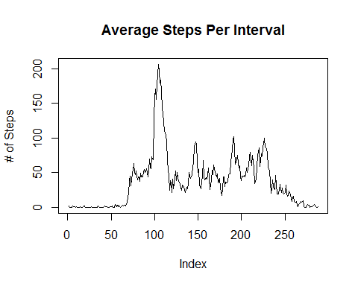

## Find interval with maximum number of steps  
  
seq(along = meanstepperint)[meanstepperint == max(meanstepperint)]

## [1] 104

## Imputing missing values

## Calculate number of missing values  
  
sum(as.numeric(is.na(actdata$steps)))

## [1] 2304

## fill in missing data  
  
##Set mean steps interval data as a vector and repeat it for the 61 days  
fillmeanstepint <- as.vector(meanstepperint)  
fillmeanstepint <- rep(fillmeanstepint, 61)  
## set value to 1 where it is not NA  
fillmeanstepint [!is.na(actdata$steps)] = 1  
  
## steps data as a vector and set to where data is missing  
fillstepdata <- as.vector(actdata$steps)  
fillstepdata [is.na(fillstepdata)] = 1  
  
newdata <- actdata  
newdata$steps <- fillmeanstepint * fillstepdata  
totstepdaynomiss <- tapply(newdata$steps, newdata$date, sum)

## Create histogram  
hist(totstepdaynomiss, breaks = 5, main = "Number of Steps Taken Per Day",  
 xlab = "# of Steps", ylab = "# of Days in Group", col = "Blue" )

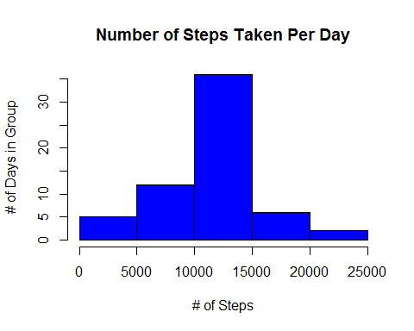

Imputing the values for missing data increases the average number of steps taken per day as can be seen by comparing the middle bar of the histograms for Number of Steps taken per day in this chart to the histogram 2 charts above.

## Are there differences in activity patterns between weekdays and weekends?

## set up weekdays and weekends  
  
days1 <- as.POSIXlt(newdata$date, format = "%Y-%m-%d")  
days2 <- days1$wday  
days2[days2 == 0] = 0  
days2[days2 == 6] = 0  
days2[days2 != 0] = 1  
days3 <- factor(days2, levels = c(0,1))  
newdata$WD <- days3  
  
weekdaymeansteps <- tapply(newdata$steps, list(newdata$interval, newdata$WD), mean, na.rm = T)

par(mfrow = c(2,1))  
  
with(newdata, {  
  
 plot(weekdaymeansteps[,1],type = "l", col = "Blue", main = ("Steps in each Interval"),  
 xlab = "Interval", ylab = "Weekend")  
 title = ("# of Steps per Interval")  
  
 plot(weekdaymeansteps[, 2], type = "l", col = "Blue",   
 xlab="Interval", ylab = "Weekdays")  
})

